
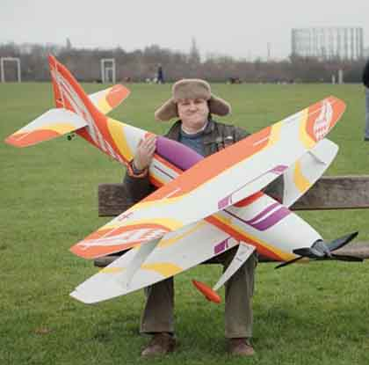Photo courtesy of Messrs Thomas Thomas Films and Joint London
MARCH – STILL HERE UNTIL APRIL - PROBABLY!

Still little to report, as flying has been impossible for weeks, and is unlikely to improve any time soon. Warren Farm seems to drain well after prolonged wet weather, but the grass is getting longer, so large wheels or hand launched models will be the order of the day when (or should that be if) the wind drops.

We understand that the legal challenge to the QPR redevelopment plan is due to be heard in court on 2nd April, so it is unlikely that work will start before then. Beyond our runway, the grass was given a first cut a few weeks ago, and was due for a second cut, however we believe that this will be delayed until at least after the court hearing.

As there has still been no progress with regard to the proposed relocation to a small area of Osterley Farm, we are now considering a different method of approach, however we have been advised to put this on hold until after the court case.

CAA REGISTRATION
All flying members of the club should now have received their CAA registration numbers, although your editor has not due to a misunderstanding with the BMFA subscription renewals.

If you have received your number, please let us know by email, as we need to keep this on our club database. We understand that we will be able to download the numbers from the BMFA website, however this may be delayed, as they have many thousands to upload from the CAA.

All flying members who do not hold the BMFA “A” or “B” Achievement Certificate will require a Registration Competency Certificate,which must be carried when flying.

These can be downloaded and printed, however if you are unable to print, please let us know so that we can print for you.

AND FINALLY
Model flying is on the tellybox again!

There is a new advertisement for the “Uswitch” comparison website, which features a short clip of a model being flown at very low altitude, along with a small inset still picture.

If anybody can identify the model, we should be pleased to learn what it is. All we know is that it is a biplane, probably ARTF, typical of the type now commonplace in F3A Aerobatic Competitions.

It is fitted with contra-rotating propellers, which some F3A competitors now use to eliminate handling problems associated with the effects of torque, gyroscopic forces and helical airflow over the fin.

We have, however, established that the video was shot at Wormwood Scrubs.

